**Bluetooth TaxiBot Project**

By

Raphael Liew Jin Cheng

Mohamad Danial

Zafrul Azim Nazir

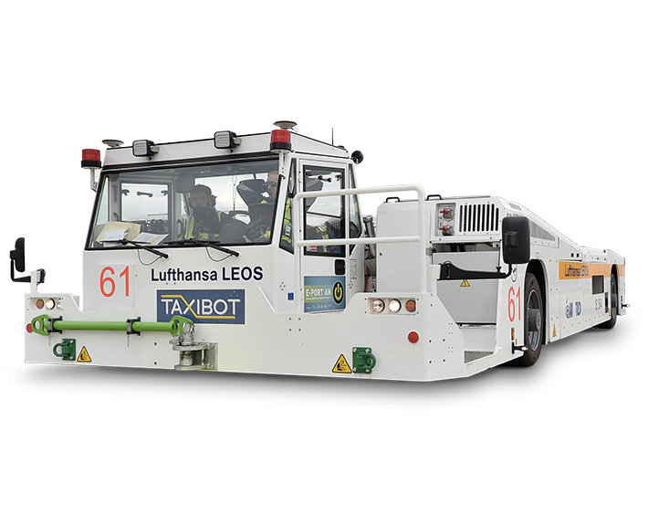

**Content page**

1. **Main body**
   1. **Introduction**
   2. **Literature review**
      1. Bluetooth
      2. Arduino Uno
      3. IC L293D
      4. Ultrasonic
   3. **Methodology**
      1. Project overview
      2. Research methods
      3. Programming methods
      4. Embedded system(flow chart)
   4. **Analysis**
      1. Schematic
      2. Components
   5. **Design**
      1. Hardware design
      2. Software design
      3. Block design
   6. **Implementation and testing**
   7. **Critical evaluation & conclusion**
   8. **Further work**
   9. **References**

**Main Body**

Introduction

The purpose of this report is to document the processes and results of the project. The objective of the project is to build a 4-Wheel Airplane Taxi Bot with basic maneuvers and controls using (Arduino codes and App Inventor’s Program). We started off, by constructing the electronic circuit (using Arduino proto-board and point to point soldering) and finally, tested the 4-Wheel Airplane Taxi Bot by controlling it remotely with a smartphone app. Not only that, we did several enhancements to the robot. In the following pages, we will be discussing, the project review, methodology, analysis, design, implementation and testing, critical evaluation and conclusion.

Literature Review

A literature review or narrative review is a type of review article. A literature review is a scholarly paper, which includes the current knowledge including substantive findings, as well as theoretical and methodological contributions to a topic. We will be sharing the history of several components of the Taxi-Bot. Not only that, we will also be talking about the existing projects or studies similar to our project.

**Bluetooth**

Dr. Jaap Haartsen from the Ericsson company was the founding father of Bluetooth technology. He founded it in 1994. Bluetooth technology was designed to replace the RS-232 telecommunication cables. The cables were first conceived in 1960 and the technology was starting to age. Bluetooth works by using short range UHF radio waves between 2.4 and 2.485 GHz. Although Wi-Fi shares similar frequencies with Bluetooth, Bluetooth has always been designed as a much shorter range and lower power alternative. In 1988. the Bluetooth Special Interest Group (SIG) was formed. Its main purpose is to publish and promote the standard and its subsequent which it still does to do this day. The special interest group initially only included, Toshiba, Ericsson, Intel, IBM, and Nokia but reached 4,000 members by the end of its first year. The group now contains over 30,000 member companies.

**Arduino Uno**

The Arduino project was started in Ivrea, Italy, in an institution known as the Interaction Design Institute Ivrea (IDII). At that time, the students used a BASIC Stamp microcontroller at a cost of $50, which many students simply cannot afford. In 2003 Hernando Barragán created a master thesis about developing a platform Wiring, under the supervision of Casey Reas and Massimo Banzi. Casey Raes created the processing development program with Ben Fry. The main goal of the project was to create cheap, simple tools for creating digital projects by non-engineers. The Wiring platform consisted of a PCB board with an ATmega168 microcontroller, an IDE based on Processing and library functions to easily program the microcontroller. In 2003, the team worked tirelessly and produced a cheaper version of the ATmega8 microcontroller to Wiring. But instead of continuing the work on Wiring, they changed the project and renamed it to Arduino.

**IC L293D**

The L293D IC is one of the most popular drivers in the market. There are a couple of reasons why the L293D is preferred over the other ICs. Firstly, it is incredibly cheap as compared to other drivers costing only about $4. Secondly, it has a convenient shape and size which makes it very versatile. Thirdly, it is very easy to use and understand. Not only that, there is no need for protective circuit and diode. It also does not need to use heat sinks and it has a good resistance to temperature and high-speed variations. Motors with a voltage between 5V to 36V can use this IC. The IC can also support a current of up to 600 mA. However, it can withstand a current up to 1200 mA in 100 microsecond and non-repetitive. The frequency of this IC is 5 kHz.

**Ultrasonic**

Scientist and researches have been studying sound waves for hundreds of years for many different reasons. However, the development of ultrasound started in 1790 when it was discovered that bats used a method of echolocation. The first scientist to discover this was Biologist Lazzaro Spallanzani. He first documented this ultrasonic ranging as their mode of flight, using their hearing to fly around and listen for the return of the high-frequency sound they emit to detect food and objects. These high-frequency sound waves allowed future researches to implement these waveforms into the future development of technology. There were a few discoveries in the late 18th and 19th centuries that aided in this development, but Spallanzani’s document was 100 years before there was an actual development that humans could harness and use. The First World War made many technological advancements in several industries especially ultrasound technology as it was needed by the military at the time. A sonar device was the first practical application of ultrasound. The early 1900s was an exciting time of discovery and development for ultrasonics, and the potential for this branch of physics and engineering was applied to many different industries. Some of these include, SONAR and RADAR.

Methodology

Project 2 overview

Research Methods:

We used all available resources available. Although we did not use books in the library, we decided to search for our results on the internet. We used platforms such as google and YouTube to figure out and understand what we wanted to achieve. This includes how we wanted our app to look to functionality side of it. An example would be implementing the slider into our MIT app. We went onto YouTube to see how fellow programmers used and programmed this feature. With the understanding from the video, we were able to implement it into our program to control the speed of our robot. When it came to figuring out how to achieve something on the programming aspect, our group chose YouTube over websites as we felt that someone explaining how to do it would allow us to understand what we were doing compared to just blindly copying.

Programming Methods:

Arduino IDE

Our basic controls and enhancement codes on Arduino IDE are organized into if-else statements. Apart from that, we used function calls to organize our Arduino codes which has helped us understand and navigate around easily.

MIT APP Inventor

Essentially, our MIT APP Inventor works by sending a text to the Arduino IDE to run the codes.

Example:

Embedded system (Flowchart)

Start

Turn left

HC-05 BT module

Arduino IDE Software

Turn right

Microcontroller

Move forward

Reverse

Motor Driver (L293B)

DC Motor 1

DC Motor 2

Analysis

Schematic:

The schematic is neat and clear, but it can be challenging to analyze. We started off our soldering with the connection of the 4 resistors, LEDs and the IO ports. From there, we joined them to the IC chip pins. Finally, we connected the Motor Pins, 5V and ground to the circuit.

Components:

The Bluetooth module we are using is the HC-05 module. The HC-05 is a class 2 Bluetooth module designed for transparent wireless serial communication. It is pre-configured as a slave Bluetooth device. Once it is paired to a master Bluetooth device such as PC, smartphones and tablets, its operation becomes transparent to the user. All data received through the serial input is immediately transmitted over the air. When the module receives wireless data, it is sent out through the serial interface exactly as it is received. No user code specific to the Bluetooth module is needed at all in the user microcontroller program.

HC-05 Bluetooth Module

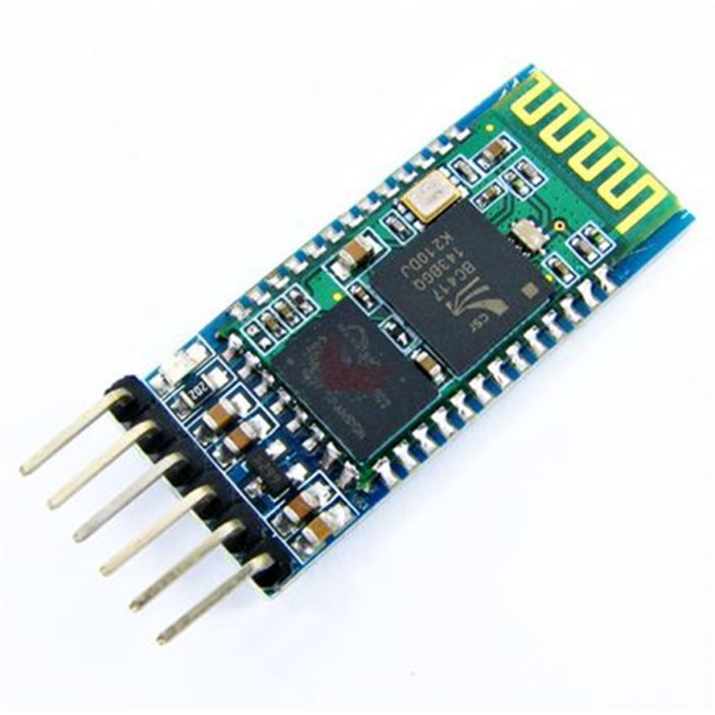

The HC-05 supports two work modes: Command and Data mode. The work mode can be switched on by pressing the onboard push button. However, The HC-05 will be in command mode if the push button is activated. In Command mode, the user is able to alter the system parameters using a host controller itself of a PC running terminal software. It works by using a serial to TTL converter. The system parameters will retain any changes made even after the power is removed. After this, the power cycle takes over the HC-05 and it will be set back to Data Mode. Transparent UART data transfer with a connected remote device occurs only while in Data Mode.

The HC-05 can be re-configured by the user to work as a master Bluetooth device using a set of AT commands. Once configured as master, it can automatically pair with a HC-05 in its default slave configuration. The HC-05 will work with supply voltage of 3.3VDC to 6VDC, however, the logic level of RXD pin is 3.3V and is not 5V tolerant. A Logic Level Converter is recommended to protect the sensor if connect it to a 5V device (=. The power to the HC-05 will cut off if the "EN" pin is pulled to logic 0.

Arduino Uno

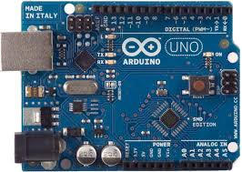

The Arduino Uno is an open-source microcontroller board based on the Microchip ATmega328P microcontroller and developed by Arduino.cc. It is equipped with digital and analog input/output (I/O) pins that can be used on various expansion boards and other circuits. The board consists of 14 Digital pins, 6 Analog pin. It can be powered by a USB cable or by an external 9-volt battery. However, it can tolerate voltages between 7 and 20 volts. It also has 7 general pins and 6 special pins. The 7 general pins are, LED, Vin, 5V, 3V3, GND, IOREF, Reset. The 6 special pins are, UART, PWM, SPI, TWI, AREF, External Interrupt. The board has a few ways to communicate with a computer, another Arduino/Genuino board, or other microcontrollers. The ATmega328 provides UART TTL (5V) serial communication, which can only be used when digital pins 0 (RX) and 1 (TX) are connected respectively. An ATmega16U2 on the board relays this serial communication over the USB. It will then show up as a virtual com port to the software on the computer. To allow simple data to be sent to and fro from the board, The Arduino Software (IDE) has a serial monitor. The RX and TX LEDs on the board will flash indicating that there is data being transmitted via the USB-to-serial chip and USB connection to the computer. A Software Serial library allows serial communication on any of the Uno's digital pins.

IC Chip (L293D)

The L293D is a Motor Driver IC. It allows the DC motor to move in different directions. It has 16 pins which allows it to control 2 different sets of DC motors simultaneously. This means that we can drive 2 different motors with a single IC. It can drive small or big motors depending on the voltage specification of each IC. It uses the concept of the H-bridge to function. The H-Bridge circuit is a circuit which allows the voltage to travel in any direction. There are two Enable pins on L293D. To drive the motor, pin 1 and 9 need to be high. To drive the motor with left H-bridge, pin 1 needs to be high. To drive the motor with the right H-Bridge, pin 9 must be high. If either pin 1 or pin 9 is low, the motor in the corresponding section will not work. It acts like a switch. There are 4 input pins for the L293D, pin 2 and 7 on the left and pin 15 and 10 on the right. Left input pins will regulate the rotation of motor connected across the left side and right input for motor on the right-hand side. The motors are rotated according to the inputs provided across the input pins as LOGIC 0 or LOGIC 1.

Design

Hardware design

Battery

BT Module

Ultrasonic Sensor

Arduino Board

DC Motor

Soldering and Wiring

Software design

Interface design

Menu: To provide us with a better user interface experience, we created a menu to navigate between the 3 screens to operate our basic controls & enhancements.

Bluetooth: When the Bluetooth button is pressed, the app will prompt the user with a list of devices ready to pair with the phone.

Basic Controls Buttons: All basic controls buttons used in our MIT APP are touch up/down buttons. E.g. Taxi bot will move forward only when pressed but stops when you let go of your finger.

Slider: Used for the PWM feature to switch between the 2-operating speed of the motor in the taxi bot.

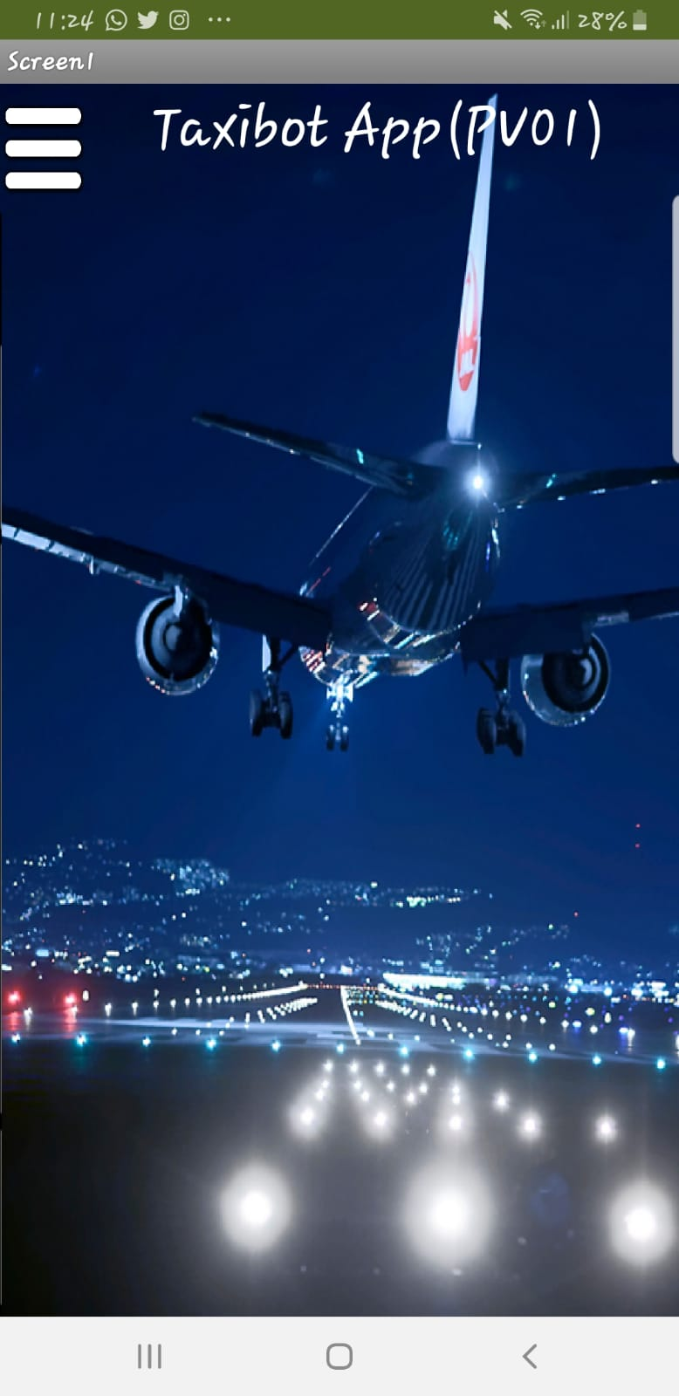

**Home page Button and voice control**

**Accelerometer**

**Side menu**

Block design

Touch Down: Sends a text to Arduino IDE software to move the robot

Touch Up: Sends a text to Arduino IDE software to stop robot’s movement

Basic Controls



Accelerometer



Proximity sensor

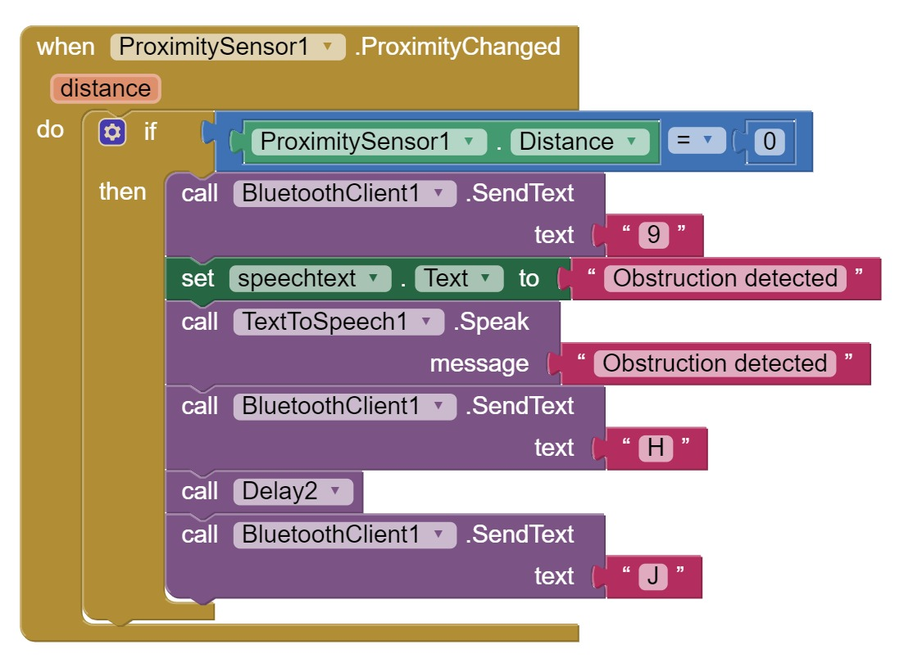



PWM control (using a slider)

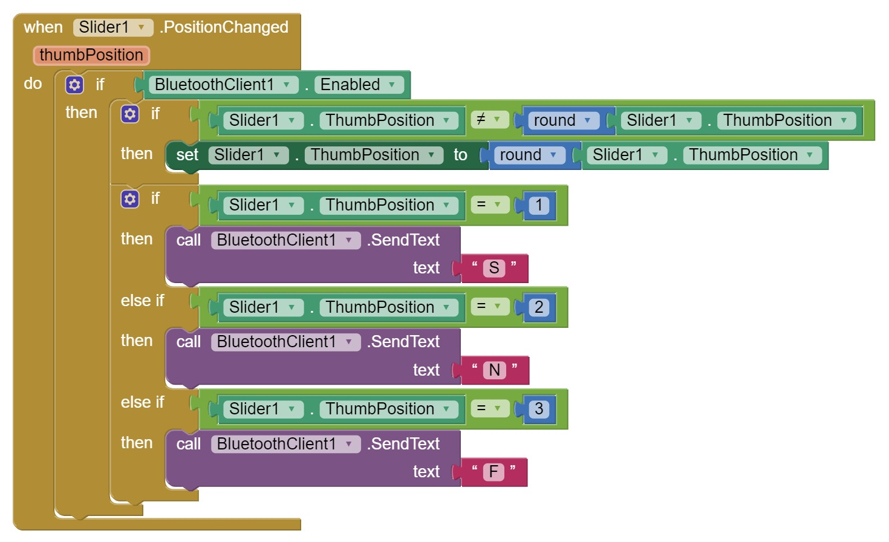



Side menu

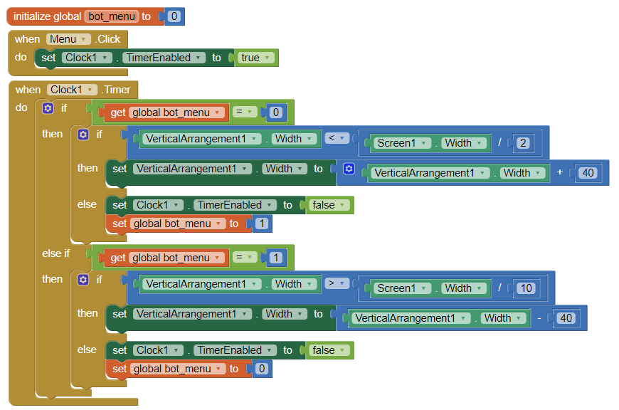



Speech Recognition



Implementation and testing

Implementation

We performed a point to point soldering on the Printed circuit board (PCB) following very closely to the schematic. After soldering all the joints, we did a point to point continuity check to ensure that the components and wires are connected. After all the connections are done, we proceeded to attach the PCB to the Arduino Uno along with the Bluetooth Module (HC-05) and the Battery. Finally, we connected our android smartphone to the Bluetooth module to test our program on the taxibot.

Testing

For testing it was very tedious. Throughout the testing phase we ended up with a lot of different versions for our MIT app as well as Arduino codes. This phase allowed us to figure out and correct problems. Testing even helped us to solve a problem we had that we could not find a solution to online.

Robot Features Demonstration flowchart

Critical evaluation & Conclusion

Evaluation

The Taxi bot is an important application in the airport. It can be remotely controlled with Bluetooth connection to tow an aircraft from the terminal gate to the take-off point and return it to the gate after. The Taxi Bot eliminates the use of airplane engines during taxi-in and until immediately prior to take-off during taxi-out, significantly reducing aircraft fuel usage, C02 emissions and the risk of [foreign object damage](https://en.wikipedia.org/wiki/Foreign_object_damage). Our setup in this project emulates a taxi bot’s basic functions and introduces enhancements which can possibly be implemented in the real world. However, there are also limitations to our setup. For example, the IC chip only allows the taxi bot to turn left/right with one motor while the other is locked in place. All in all, from cutting cost to making airports more economical and environmentally friendly, there are a lot of potential to this embedded system that can be used to improve operations in the airport and beyond.

Conclusion

This project has equipped us with a strong engineering foundation as well as a firm grounding in the design and application of electronics in aviation industry. We did face a lot of challenges in this project, but we managed to work together and with research, overcame these challenges to finish our robot. The knowledge learned from the hardware and software portions of the project will be a useful skill for us when we enter the workforce. Also this project taught us how important it is to work together as a team which is a common thing in the aviation industry whether be it on the apron, the hanger and even in the cockpit.

Further work

There is an endless number of possibilities for improvement on the taxibot. Our robot currently has features such as voice command, speed control, accelerometer control (tilting the phone) as well as a proximity sensor on the smartphone. However other features could possibly be added to the robot as well. One example could be an ultrasonic sensor which can aid the robot into avoiding obstacles. Another example would be a location feature. This would mean that we can track the robot’s location live on a map and this will be very useful when taxibots are rolled out in a large quantity across the airport. This location tracking would allow controllers in charge of the airport’s roads to monitor these robots and ensure that they move around the airport safely and efficiently.

# References

<https://electrinostore.com/products/37502>

<https://www.androidauthority.com/history-bluetooth-explained-846345/>

<https://maker.pro/custom/projects/all-you-need-to-know-about-l293d>

<https://www.americanpiezo.com/blog/history-of-ultrasound-technology/>

<https://www.rakeshmondal.info/L293D-Motor-Driver>

<https://howtomechatronics.com/tutorials/arduino/arduino-and-hc-05-bluetooth-module-tutorial/>

<https://learn.sparkfun.com/tutorials/what-is-an-arduino/all>

<https://www.rlf.org.uk/resources/what-is-a-literature-review/>